puzzle - Sound Sensor 声音传感器

产品简介

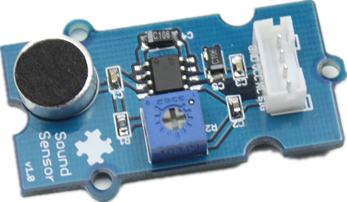
puzzle - Sound Sensor是一个简单的麦克风。它是基于LM386以及电极麦克风制作的，能用于探测环境声音的强度。输出信号的增益可以通过板上的一个电位器调节。

规格参数
工作电压范围: 4 - 12V
工作电流(Vcc = 5V): 4 - 8mA
电压增益(VS= 6V, f = 1 kHz): 26dB
灵敏度(1Khz): 52- 48dB
阻抗: 2.2KΩ
探测频率范围: 20 - 16Khz
信噪比: 54dB

应用示例

下面的示例演示的是如何用声音传感器来控制一盏LED灯。当环境音量比阈值高时，LED灯将亮起。

// Function: If the sound sensor senses a sound that is up to the threshold you set in the code, the LED is on for 200ms.
// Hardware: puzzle - Sound Sensor, puzzle - LED

/*macro definitions of the sound sensor and the LED*/
#define SOUND_SENSOR A0
#define LED 3 // the number of the LED pin

#define THRESHOLD_VALUE 400//The threshold to turn the led on 400.00*5/1024 = 1.95v
void setup()
{
Serial.begin(9600);
pins_init();
}

void loop()
{
int sensorValue = analogRead(SOUND_SENSOR);//use A0 to read the electrical signal
Serial.print("sensorValue ");
Serial.println(sensorValue);
if(sensorValue > THRESHOLD_VALUE)
{
turnOnLED();//if the value read from A0 is larger than 400,then light the LED
delay(200);
}
turnOffLED();
}

void pins_init()
{
pinMode(LED, OUTPUT);
pinMode(SOUND_SENSOR, INPUT);
}
void turnOnLED()
{
digitalWrite(LED,HIGH);
}
void turnOffLED()
{
digitalWrite(LED,LOW);
}

参考资源
- puzzle - Sound Sensor Eagle files
- LM386pdf
- how to upload code

